

Manual ImageJ – CAM Intelligent Scan

MANUAL for IMAGEJ – CAM
INTELLIGENT FIXED SCAN
1.) Intention
2.) Requirements
3.) Distribution and support (please read carefully!)
4.) Installation of ImageJ, PlugIn and Macros
5.) Checklist for Configuration of LAS AF
6.) Checklist for Configuration of Matrix software
7.) Checklist for Configuration of FixedSample_Tiling Macro
8.) Experiment Settings within MatrixScreener

- Intention
The aim of using the FixedSample_Tiling Macro together with the HCS-A software (here called MatrixScreener) is to implement the following feedback loop:
Image acquisition with MatrixScreener -> image analysis with external software (here ImageJ) -> automated feedback of object positions to MatrixScreener -> acquisition of objects with secondary scan (i.e. high resolution scan).
For further information please read the document “ImageJ – CAM Intelligent Scan” by Sebastien Tosi. These solutions bases on a collaboration contract from 15th of July 2011 between Leica Microsistemas S.L. Spain and Institute for Research in Biomedicine, Barcelona.
Many thanks to Dr. Julien Colombelli and Dr. Sébastien Tosi from the IRB.

- Requirements
Leica SP5, SPE or LSI, LAS AF software, MatrixScreener software with CAM licenses; ImageJ-Bundle Fiji.

- Distribution and support (read carefully!)
The ImageJ-CAM-Intelligent Scan described in this manual is a proof of principle. Leica cannot support ImageJ, the customer has to care about the adaptation of the image analysis for his needs by himself. Leica i.e. the local field support specialist supports the configuration of the MatrixScreener to run the proof of principle experiment. Furthermore the specialist will explain the positions in the image analysis macro (i.e. the FixedSample_Tiling.ijm), where the analysis functions can be edited.
- Installation of ImageJ, Plugin and Macros
To ensure proper function of the tool a dedicated ImageJ version has to be installed. This version will be delivered together with the necessary plugins and macros. ImageJ will be part of a software bundle, which is called Fiji (Fiji Is Just ImageJ). It can be installed via copy deployment (copy-paste instead of an installation). This should be done on the PC controlling the LASAF via CAM; in most cases this will be the LAS AF-/Matrix PC, but it is also possible to run the image analysis on an external PC connected via LAN (in this case: take care, that the image folder is shared between Matrix and ImageJ).
- Copy Fiji to designated PC (e.g. D:\program files\Fiji).
- The macro should be compatible with the last FIJI version but it is still a good measure to disable FIJI updates once you got it to run properly (click “Never” when it is popping up), or at least to keep a backup of a compatible version.
- Copy LASAFClient.jar into plugin folder of Fiji software (Fiji.app->plugins).
- Copy FixedSample_Tiling.ijm and e.g. the AnalysisFunctions_Fixed_Tiling.ijm into macro folder of Fiji software (Fiji.app->macros).

- Checklist for Configuration of LAS AF
- Configuration->IPS masks: untick the option “additional z positions” to ensure no offset between channels due to different z-wide recorded positions.
NOTE: This is the only setting which must be performed each time LASAF is restarted!

- Checklist for Configuration of Matrix Software (only once)
Matrix Screener->Application->Configuration (upper right corner):
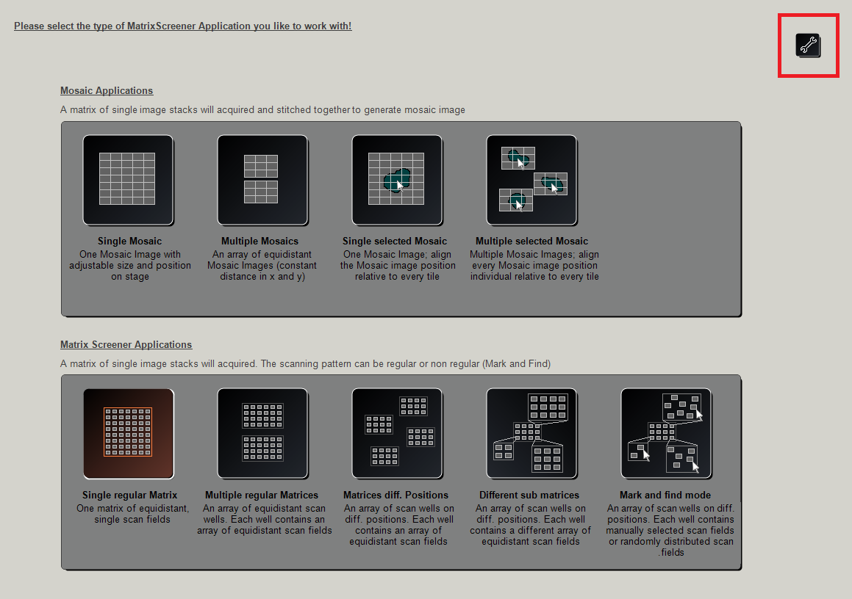
- In Media Path Settings enable AutoExporter module loaded and Image Deletion After Successful Export.
- Setup a folder where the images will be exported and set its path as the Media Path.
- In the LIF converter settings tab fill in the experiment and metadata folder names (e.g. "scan" and "metadata"), set the timestamp format field to "YYYY_MM_DD_hh_mm_ss".
Empty all remaining fields (slide, well, field) to obtain a flat hierarchy for the files of a given scan.
- Stage Settings A: for correct movement of the sample in relation to movement in the map of the scanning template and for correct formation of the mosaic montage.
DMI6000 with Wiener Stage: Application Settings-> Settings (Page 1)->Stage Co-ordinates (learning distances) activate Invert X-axis.
SP5: Adjust rotation for all LASAF-Jobs (around 90°, fine adjustment with rotation correction in Matrix Software, right-click on scanning template map, see there).
SPE: For correct mapping of movements: well and field distances have to be corrected with negative values in Setup Template->Experiment Adjustment->Well/Field Distance.
LSI: For correct mapping of movements: well and field distances have to be corrected with negative values in Setup Template->Experiment Adjustment->Well/Field Distance.
For other stages/combinations:
Check with a sample, if movements within the template map are in relation to movements of the live image (before set up a matrix upon your sample e.g. 2x3 wells, 1 field each, with a well distance of 100µm). If the moves correspond to the selected map locations then the X/Y axes stage configuration is valid. If not, you should modify this configuration in the settings tab of the matrix screener Application Settings-> Settings (Page 1)->Stage Co-ordinates (learning distances) for instance if the X/Y moves are inverted use X/Y flip, if X moves are inverted use invert X and so on.
NOTE: one should close the MatrixScreener wizard after changing a value! Before closing the wizard ensure, that you saved the experiment setup.
If settings cannot be adjusted for correct movement: well and field distances can be corrected with negative values in Setup Template->Experiment Adjustment->Well/Field Distance.
Stage Settings B: for correct movement of the sample according to selected locations in the image (Auto-Center function by pressing Alt+Left Mouseclick in the live image).
DMI6000 with Wiener stage and SP5:
Application Settings-> Settings (Page 2)->Auto Center of image objects: “Invert x” and “Flip xy”.
In case of other hardware configurations:
To do so use a sample with an embedded reference basis and adjust the orientation of the sample in live mode as it is shown in the eyepieces. (Alternatively you can align a reference point or line of your sample to the border of the field of view). Enable the target tool by pressing Ctrl+T and try to move around the sample by using Alt+left click. If the moves correspond to the selected locations then stage configuration is valid. If not you should modify this configuration in the settings tab of the matrix screener: Application Settings-> Settings (Page 2)->Auto Center of image objects: for instance if the X/Y moves are inverted use X/Y flip, if X moves are inverted use invert X and so on.
- Checklist for Configuration of FixedSample_Tiling Macro (only once)
- Open Fiji Software -> open Macro Editor (Plugins->Scripting->Script Editor) -> open FixedSample_Tiling Macro (Fiji.app->macros) within Script Editor.
(Alternative: simply drag the macro file into the Fiji software window)
- Implement stage settings for correct mosaic montage:
In the first 3 lines of the macro you can set the correct stage parameters as in Matrix Stage Co-ordinates (learning distances):
x not inverted: xSign = 1
x inverted: xSign = -1
y not inverted: ySign = 1
y inverted: ySign = -1
xyFlip no: xyFlip = 0
xyFlip yes: xyFlip = 1
- Set correct IP for communication between Fiji and Matrix via CAM interface:
Open DOS command prompt (Windows Start-> type “cmd” -> type “ipconfig”)
Set IP address of LASAF-PC as default value for " DefaultLasafIP"; if Fiji and LASAF are running on the same PC type: “127.000.000.001” for the local host.
"DefaultLasafPort" should be 8895.
- Copy "FixedCAMAnalysis.ijm" to Fiji macro folder and optionally open it in the macro editor for edition. If the file is properly copied you should see a log window with the names of the user defined functions that are registered from this file when launching the FixedSample_Tiling macro.
- Experiment Settings within Matrix e.g. for kidney slice sample
- Select Application: Multiple Regular Matrices
- Setup Template:
Load experiment settings or define new experiment; settings for kidney slice with 20x objective e.g. 3x2 fields.
Field distance is same as field of view of the objective (see size in LASAF) to build a continuous low resolution map without overlap.
- For a new template: define 3 Jobs (exact names for correct function of FixedSample_Tiling-Macro must be: AF Job, Job low and Job high)
AF Job will perform a focus map.
Job low is an example for a primary scan used for creation of a mosaic montage of the kidney slice as basis for the image analysis via Fiji.
Job high is the secondary scan job as an example for a secondary scan carried out at the object positions detected in the primary scan.
- NOTE: sometimes LAS AF do not allow to create a job with exact name "Job high" because the user previously removed a job with such name. The macro can still be run but by updating the name in the configuration dialog box.
- Note:
Job low and Job high should use the same objective (not necessary if the parfocality and xy-calibration of objectives used is very good).
The rotation of the field of view is set so that the image borders are parallel to the stage axes (the computed xy offsets are only valid under this assumption).
In case of the SP5 with DMI6000 the scan rotation should be +-90° (fine adjustment is set with right click on matrix scheme->Adjust Matrix Angle).
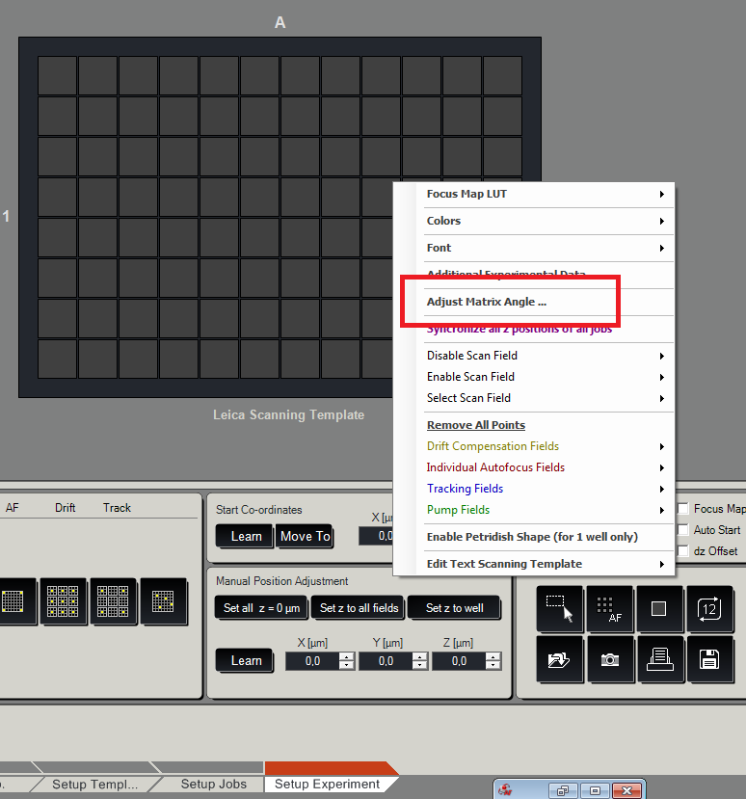
In Setup Experiment the CAM Checkbox must be ticked.
- Position the sample on the microscope and adjust the focus with the z-wide control. Note that the sample should only be positioned now as the templates might keep the objective configuration and the objective change is performed without prompt.
- Setup Jobs: Adjust the channel gain and laser power for both low resolution (primary scan) and high resolution (secondary scan) jobs.
- Setup Template: position the stage to the upper leftmost corner of the region to be scanned (either by using the microscope controls or by using alt+click in live mode, you can also use ctrl+T to show a centered target). Press “learn” to record the current XY position of the stage.
- Setup Experiment: Assign the primary scan job to the scan grid. Assign the current z position to all the wells (starting position of the autofocus) with "set z to all fields". The autofocus range and step should be adjusted to allow a good operation.
- Optional: Launch the autofocus scan.
- Make sure the "CAM" tick box is ticked.
- Make sure the primary scan job is active (selected in the jobs list) and launch the FixedSample_Tiling macro (Open Fiji Software -> open Macro Editor (Plugins->Scripting->Script Editor) -> open FixedSample_Tiling Macro (Fiji.app->macros) within Script Editor.
(Alternative: simply drag the macro file into the Fiji software window)
Select the folder that has previously been setup as data export folder (do not enter inside the folder, just select it and click ok).
NOTE: In the last version of the CAM a subfolder called "subfolder" is created by default in the experiment folder by LASAF. To ensure compatibility it is necessary to create it manually inside the experiment folder and to select this subfolder at this step.
- In the dialog box fill in job name for secondary scan accordingly to the name defined in the scan template. The default IP and port name should be correct.
- Select the desired options and press OK (as a first test it is suggested to set "automatic pre-analysis" to "None" (manual selection mode).
- If the primary/secondary scan jobs use multiple z slices it is important to set the focus plane at the right position in the stacks. The default position is in the middle of the stack but this does not always correspond to the requirement of the experiment.
- The macro detects the number of z slices and displays the maximum intensity z projection. In case of having multiple channels (sequential scan) the macro also automatically performs the mixing of the channels to a RGB montage (up to 3 channels). This color mixed, maximum intensity z projected image is the image that is passed to the automatic analysis function.
- The CAM requires that a scan is running to accept points in the CAM list and acquire theses positions. Since the macro waits for the end of the scan before processing the images it is necessary to re-launch the scan (assigned scan) to launch the secondary scan. The scan can be fastened by assigning a "dummy job" to the scan grid just before starting the secondary scan (the macro will show a dialog box prompt to give you the opportunity to assign a dummy job). This dummy job should optimally be configured with minimalist settings (no laser power, no averaging, no z slice, single channel, ...). It is however extremely important that the zoom factor and the image size in pixels be identical to the primary scan job.
DETAILS ON THE OPTIONS OF THE DIALOG BOX OF THE MACRO
- Perform primary scan: After a scan has been performed it is possible to launch a new scan without repeating the primary scan. In this case only the secondary scan will be performed (possibly on different targets).
- Send CAM scripts: Only disable it for debugging purpose (for instance while designing the analysis function "offline").
- Micro-manager mode: Un-tick when using LASAF to drive the microscope.
- AF drift compensation: Experimental.
- Display quick view montage: Display a montage with views centered on the detected targets. secondary/primary scans ratio: only indicative and used to set the size of the views around the targets in the quick view montage. If properly set the quick view should approximately represent the field of views of the secondary scan. Quickview scale: rescaling factor of the primary scan images displayed in the montage.
- Display secondary scan images: If many secondary scan images are acquired you should un-tick it to avoid that Fiji runs out of memory. Note: this would however not affect the secondary scan though as the images are only opened once the scan is finished.
- Automatic pre-analysis: The analysis function that should be used. If set to None the targets are manually defined (easy way to check the microscope bridge configuration).
- No scan, no analysis, only open secondary scan images: If ticked no scan is performed but the user can open the images from a past scan. This operation can be performed from any computer as long as the scan folder containing the CAM images (the second folder that is created) is saved "as is" in a specific empty folder selected during the first step of the macro. The primary scan map with the targets (montage) should also be kept (automatically saved with name matching the scan folder name) and opened before launching the macro. To open the secondary scan images of some specific positions just type in their labels (from the montage) in the dialog box.
This option is quite useful as the image files are saved by the software with a special indexing (when various targets are in the same well) and it is not straightforward to retrieve the well and image indexes from the montage labels.
- No primary scan, only resend secondary scan: Repeat the same secondary scan.

ANALYSIS FUCNTION "OFFLINE" DEBUGGING NOTE
It is easy to debug any of the analysis functions "offline". If the debugging is performed on the microscope computer one only need to stop the macro just after the primary scan (only a single folder created inside) and launch "RegionScanner" with the options "Send CAM script" and "Perform primary scan" un-ticked. If the debugging is performed on a different computer the root scan folder should be copied and selected when running the macro.
Note: When working on a remote computer even if "Send CAM script" is left ticked the CAM commands will actually not reach the microscope as long as the local IP address is used (but the computer will hang during network timeout as no server will be reached).
Warning: setting the actual microscope IP the commands will be sent (remote analysis)!
AUTOFOCUS MAP NOTES
- When the autofocus is launched the current z position of the first well corresponds to the middle plane used by the autofocus.
- For samples with an embedded reference (e.g. Cytoo chip) if the matrix angle calibration is performed a standard job must be active, not the AF job. An alternative is to adjust the sample manually.
- AF map is not interpolated for the disabled wells.
- Setting z to all field overwrites the AF map.
- The absolute stack position in the jobs is not important, what matters is the plane which is set to focus plane (by default the middle plane) and its relative position to the upper and lower positions.
- There is a small issue with the file naming when multiple images are in the same well. The new CAM convention is to append "--"+number, the old way "_"+number. The macro is ONLY compatible with the new CAM convention (this is only important when opening a past experiment).

